March 21, 2025

Montana Fish, Wildlife & Parks
Attn: Ethan Lula
Ethan.Lula@mt.gov
490 N. Meridian Rd
Kalispell, MT 59901

RE: Ray Kuhns WMA Forest Habitat Improvement and Fuels Reduction Plan Draft EA

Dear Ethan,

On behalf of our 400+ members of the Flathead Audubon Society, we support Montana Fish, Wildlife & Parks (FWP) proposed Forest Habitat Improvement Plan for the Ray Kuhns WMA as it will help provide long-term habitat diversity, reduce risk of high intensity wild fires, help restore and maintain seral ponderosa pine trees and stands, and maintain improve health of older trees and stands. We encourage retention and recruitment of larger Ponderosa pines and Western Larch as these trees and future snags are extremely important for a wide variety of nesting birds from American Goshawk and Great Gray Owls, to a wide variety of woodpeckers, to songbirds such as Western Bluebirds and Black-capped and Mountain Chickadees.

As you know, we were aware of a nesting pair of Great Gray Owls on the Ray Kuhns WMA but were not aware that one of the pair was likely killed in a vehicle collision. We understand you will be monitoring the area for nesting Great Gray Owls to help reduce impacts from the habitat improvement activities. However, it would be great if you could maintain the silvicultural prescriptions for Great Gray Owls in the unit(s) where the pair was likely nesting and in other suitable areas. Based on verbal information from our members, the pair was historically located near the northern end of the Kuhns WMA of Kuhn Rd (Unit 4 or 5) and was often seen or heard in the meadow habitat.

Below are forest silvicultural recommendations for Great Gray Owl nesting territories:

Nest habitat requires large, broken‐topped snags, usually greater than 24 inches in diameter, within 600 to 845 feet of meadows or large meadow complexes (e.g. >26 acres), and within forest canopy cover of at least 60% canopy closure immediately around the nest site. (USFS) and from E. Bull et al. technical paper:
https://www.sierraforestlegacy.org/Resources/Conservation/SierraNevadaWildlife/GreatGrayOwl/GGO-Henjum90.pdf

Great Gray Owls will also use artificial nest structures. Flathead Audubon would be willing to help with construction of such a structure if suitable nesting habitat is limited. https://nestwatch.org/learn/all-about-birdhouses/birds/great-gray-owl/

We appreciate FWP’s efforts to locate the Great Gray Owl and other nesting sites & trees with excavated cavities prior to implementing the proposed plans.

Thank you for the opportunity to comment.

Sincerely,
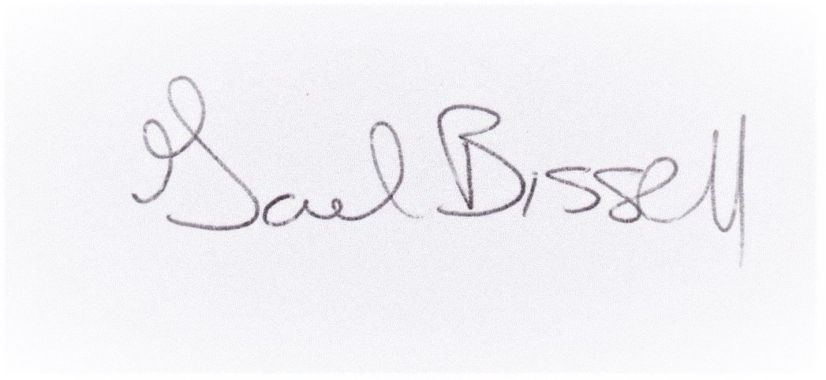
Gael Bissell, Conservation Committee Co-chair on behalf of
Flathead Audubon Society Board of Directors

